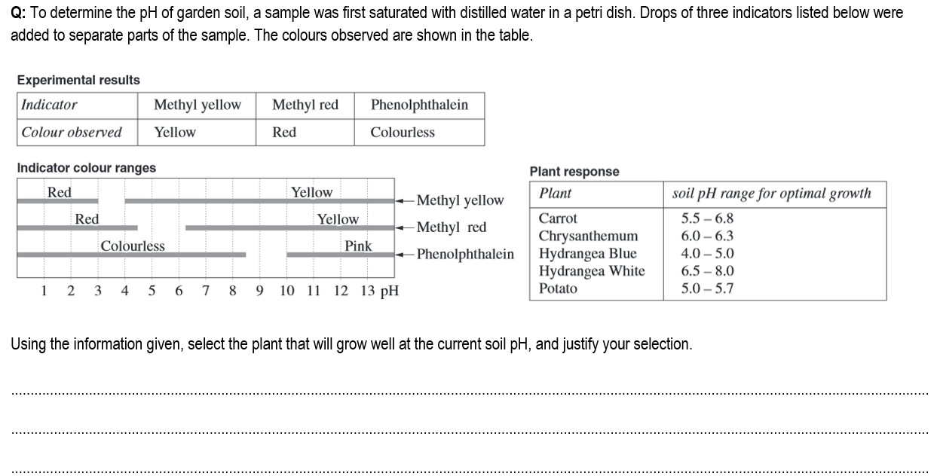

**Hydrangea Blue------- 4.0- 5.0 ------Colours observed will appear in this pH range.**